Final Project for CDA3331C

Intro to Microprocessors

Robert Harmison

Misael Concepcion

Florida Atlantic University

Abstract

The project we have chosen is the car window control system in Chapter 14 of the text book Programmable Microcontrollers with applications. The focus is to provide students with real world applications of using a microcontroller. Our main challenge was to see if we could build from a basic description in the text book into a workable model. It involved acquiring the parts, assembling them onto a bread board, writing the code in the Code Composer Studio (CCS), compiling the code to the MSP430 microcontroller, and making the stepper motor work. Robert sent in for the parts and assembled the board, while Misael wrote the code to drive the motor. We are very pleased with the results of being able to put to practical use the skills we have learned in this introductory course in microprocessors. Hopefully in the future we can build more complex projects to advance our skills as programmers and engineers.

Background

MSP430 description, how it works, specs, how it relates to the project, and the project. The MSP430 is a low power microcontroller with a, 16-MHz CPU, 16 bit reregister's, 16KB flash RAM, 2 ports with 8 I/O interfaces, a system clock, two timers and a watchdog timer. The 16 MHz CPU uses RISC (reduced instruction set computing) that uses 27 imbedded instructions and 24 created instructions. (Unsalan, 2014) The CPU also contains an arithmetic logic unit (ALU), 4 registers, (R0-R3; program counter, stack pointer, status register, and constant number generators). It is the driving force for the I/O instructions and the algorithm used for interpreting the commands sent to it by the user. The project was to build a working window control system complete with two interrupt switches, the child safety and the hold and two directional switches. The child safety stops any movement from occurring, and the hold stops the motor from continuing its rotation. There are two directional buttons for up and down movement. When the up or down button is pressed the window will fully open unless the hold button is activated.

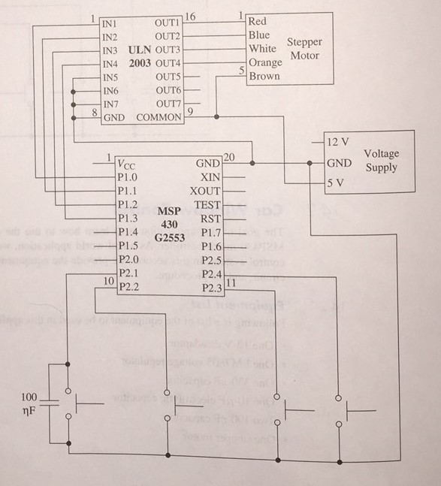

Board components:

1 - 9V DC power supply

1 - 9V DC connector

1 - N4004 Diode for the voltage regulator

1 - 330 ohm resistor for the voltage regulator

1 - LM78M05BT voltage regulator

1 - 330-nf capacitor

1 - 10 - uf electrolytic capacitor

2 - 100 - nf capacitors

1 - Stepper motor

1 - ULN2033 motor driver

4 - Push buttons

1 - Bread board

1 - MSP430 Micro Controller

All of these were acquired through the parts lab at FAU Engineering East.

Assembling the board

The board is relatively easy to setup, the wires to the stepper motor are extremely small and are easily pulled out. The ULN2033 motor driver is an IC chip that is essentially Darlington pair transistors to switch properly the current to the coils in the motor. The fixed voltage regulator circuit takes the 9 volts and drops it down to the 5 volts needed to drive the stepper motor. We also employed the use of the N4004 diode as protection to the voltage regulator as taught to us by Mr. Perry. The capacitors are used to regulate the voltage and keep the input signals from bouncing too much causing interference when they are bring processed. The four push buttons are used for the input to the microcontroller.

Pseudo Code

Include the preprocessor directives.

Declare the global variables; Safety (Child safety bit) and Save (Location of window).

Prototypes for the 2 functions of clockwise or counter clockwise

Initialize the ports for I/O

Initialize the Interrupt instructions for port 2.

Set the CPU into sleep mode awaiting instructions.

When the interrupt occurs the if statements check to see what conditions are met to enact different functions.

The first if statement toggles the safety bit.

The next two if statements check to see which button has been pressed, counter or clockwise rotation, the safety, and the Save variable for the location of the window. It then goes to the function for the counter or clock respectively; they are both the same just the arrays are in reverse order for the stepper motor. There are two for loops the inner counts cycle of the step function; the outer loop does 3 revolutions of the stepper motor.

A break is added in an if statement that checks to see if the stop button has been pressed, this stops the function and saves the location of the window to Save variable so the window can stop at its correct location.

Clockwise and counter clockwise function initialized the constant variables for the output to the stepper motor for the different coils needed to make the motor spin with the different gear ratios. That part was not easy to do. First the steps are not 1, 2, 3, 4, instead it's 1, 1&2, 2, 2&3, 3, 3&4, 4, 4&1. The other tricky part is that on the motor driver, it's inverted, so whatever input values you come up with you have to find its compliment. We are using a 200 ms delay for the motor to be able to spin, its 2000 delay in the code.

Conclusion

This project was very satisfying to work on. It allowed us to implement a real world application to the theory we have been learning in class and in the lab. It has been difficult, but did teach us to work together, divide and conquer, get the parts in a timely fashion, and execute the plan. In planning a head and breaking up the work, we had some stumbles along the way but were able to overcome these and get the project competed. We have not given up, just running out of time, but we will have it running by tomorrow evening after this has been submitted. We would recommend doing one of these projects to prospective students wanting to enrich their learning by doing something that can be used in an everyday application.

References

Angeli, E., Wagner, J., Lawrick, E., Moore, K., Anderson, M., Soderlund, L., & Brizee, A. (2010, May 5). General format. Retrieved from http://owl.english.purdue.edu/owl/resource/560/01/

Gurhan, H. D., & Unsalan, C. (2014). Programmable Microcontrollers with Applications. McGraw Hill.

Texas Instruments website, Product Specifications. Retrieved from

www.ti.com/product/LM7805 December 10 2016 from website